Complete network stack

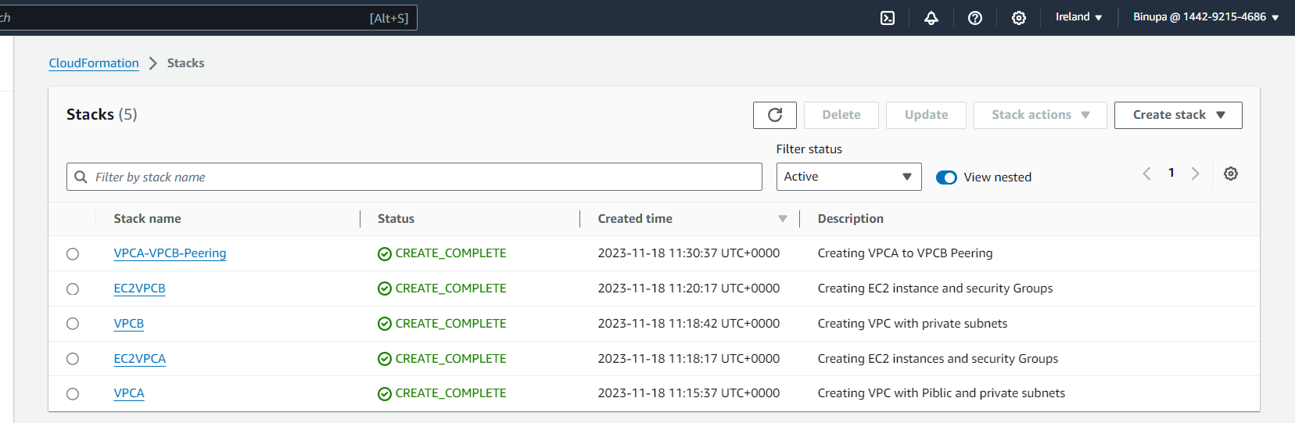

Stack -VPCA with private, public subnet, internet gateway, public route table, and private route table

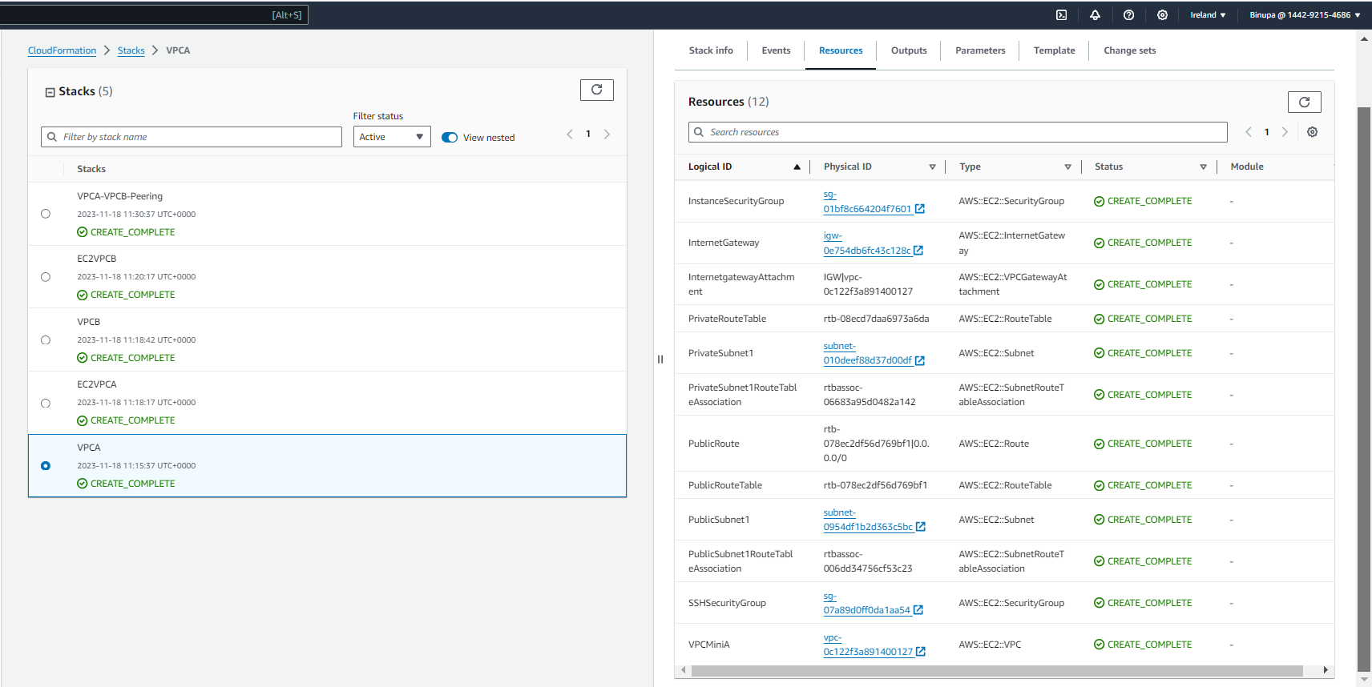

Stack-EC2VPCA one EC2 instance(Jump-box) in public subnet and EC2 instance in private subnet and security groups

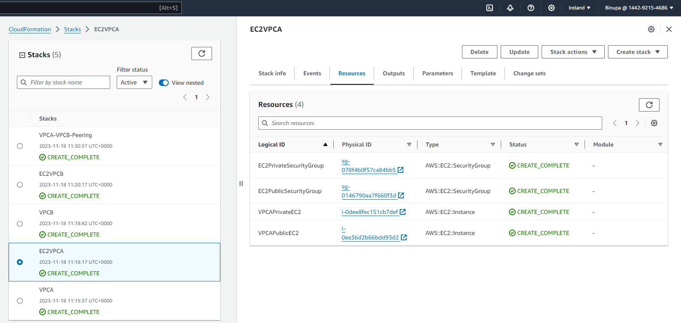

Stack-VPCB one private subnet and route table

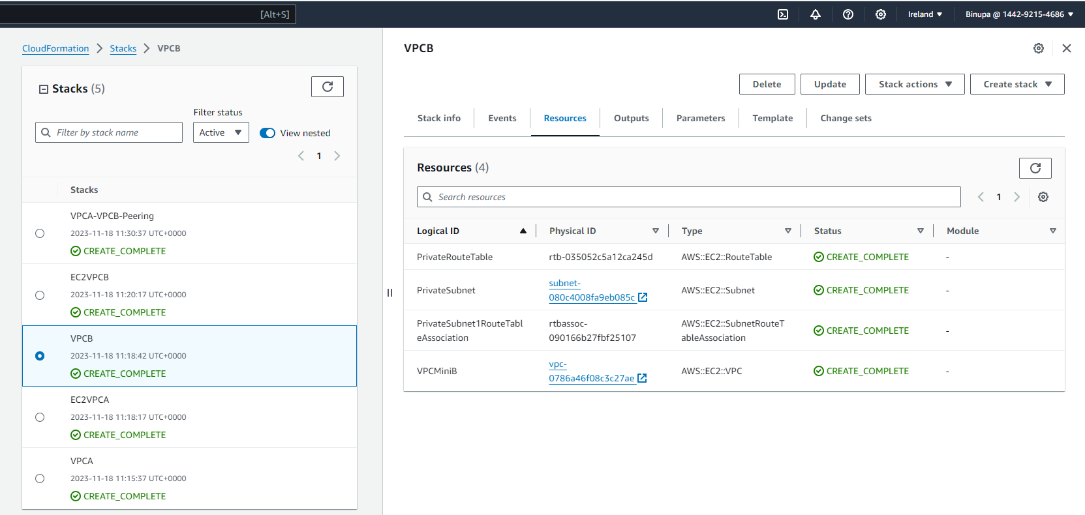

Stack-EC2VPCB one private subnet and route table

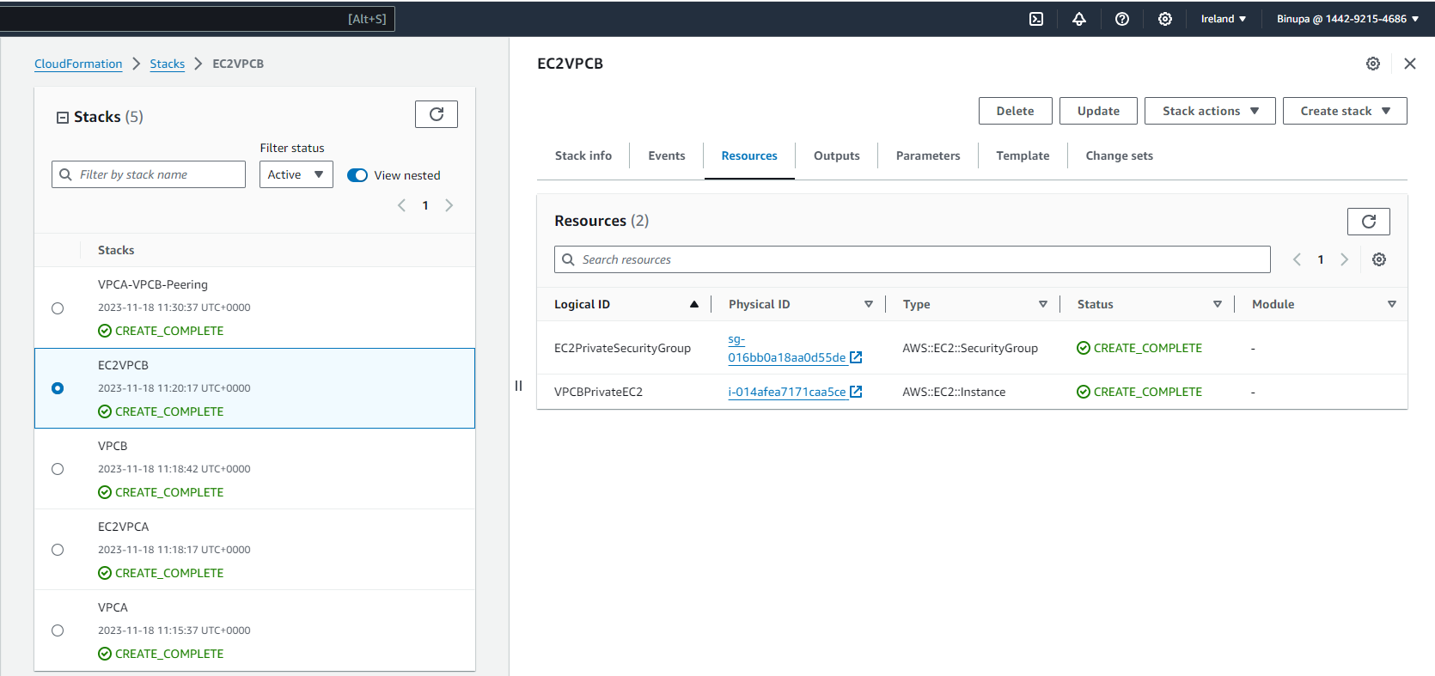

Stack-VPCA-VPCB-Peering

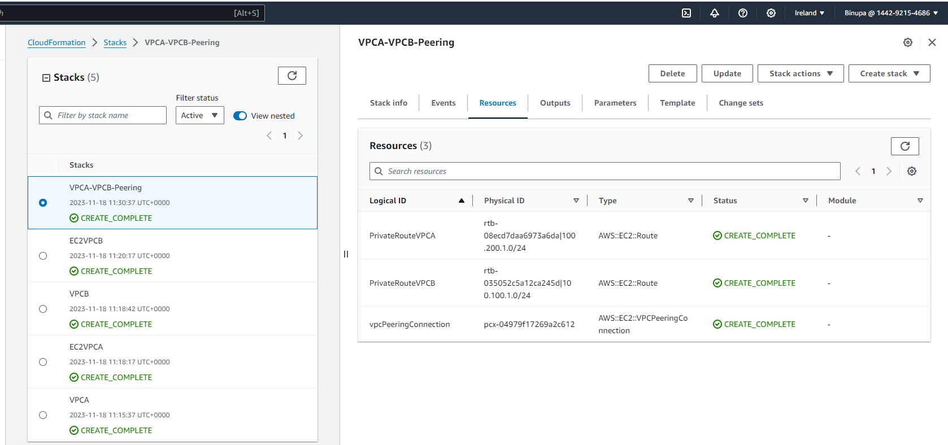

EC2 Instances

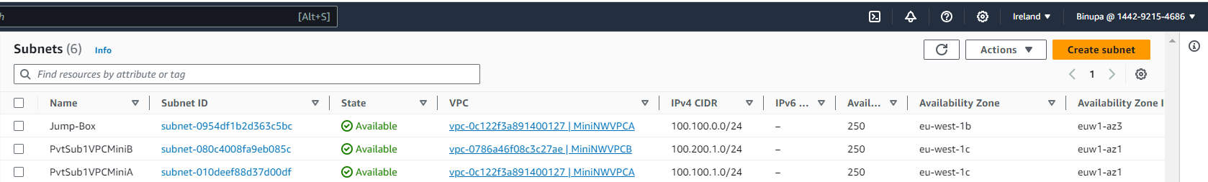

Private route table for VPCA rote added for VPC peering

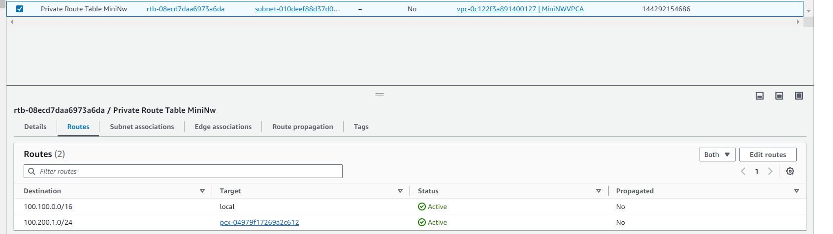

VPC peering – VPCA to VPCB peering

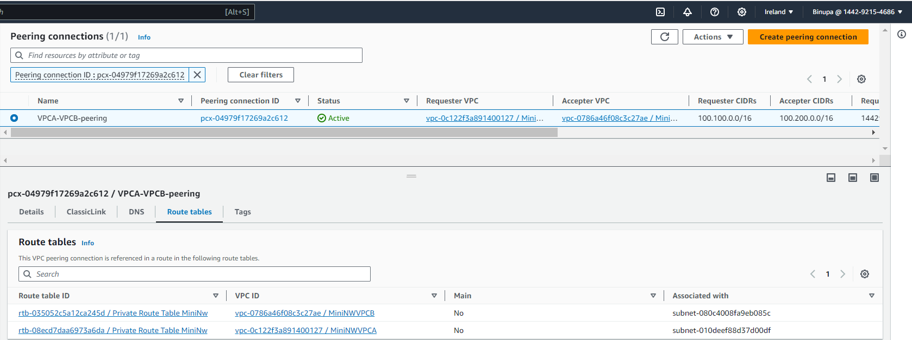

Private subnet route table in VPCB, route added for VPC peering

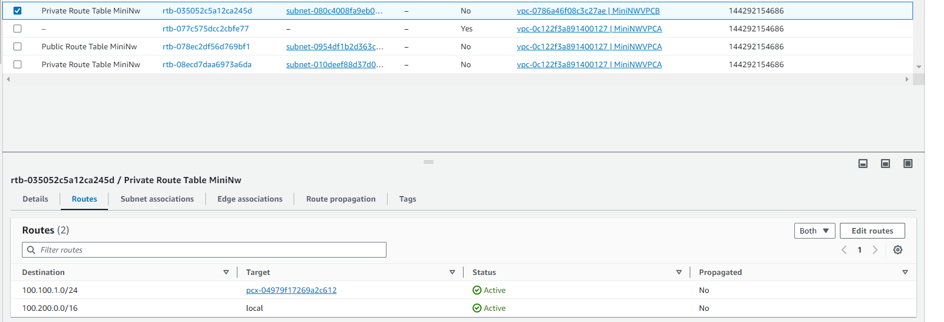

Connecting to jump-box

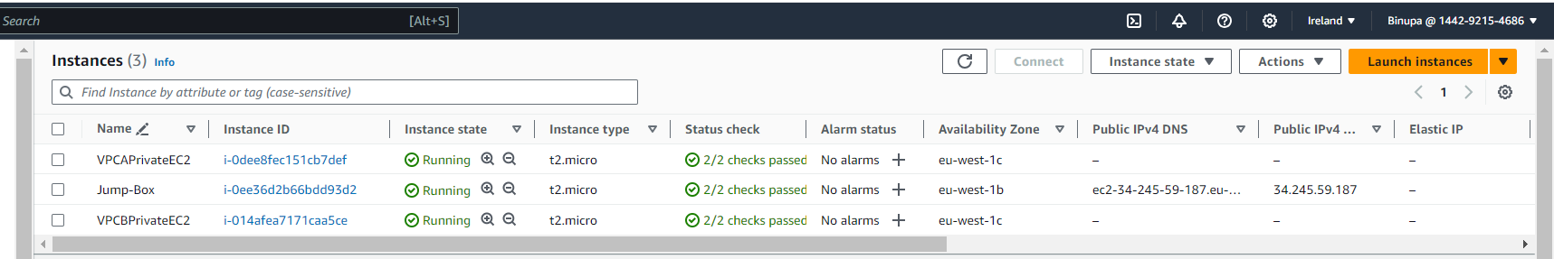

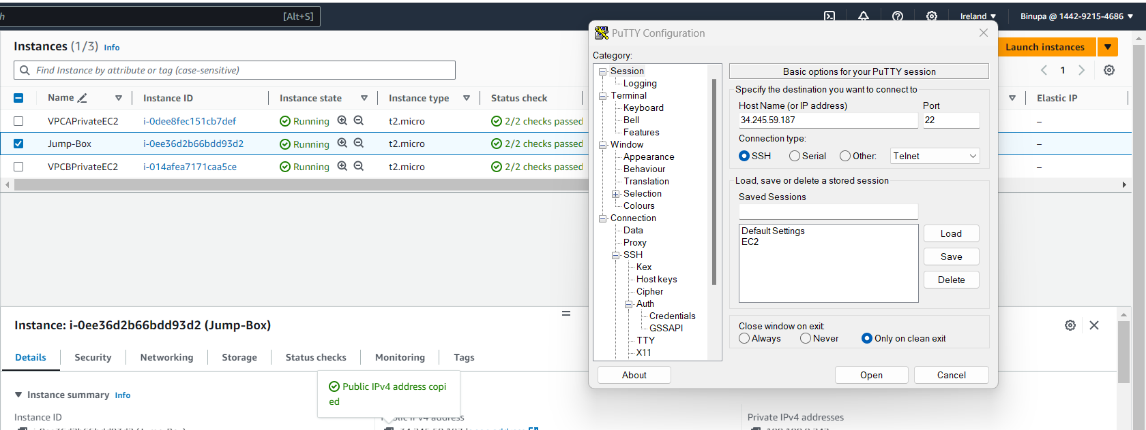

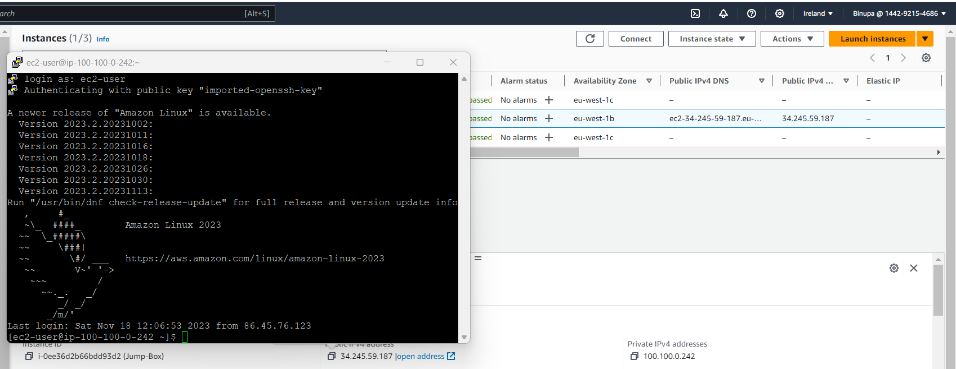

SSH connection from jump-box to VPCA private subnet instance

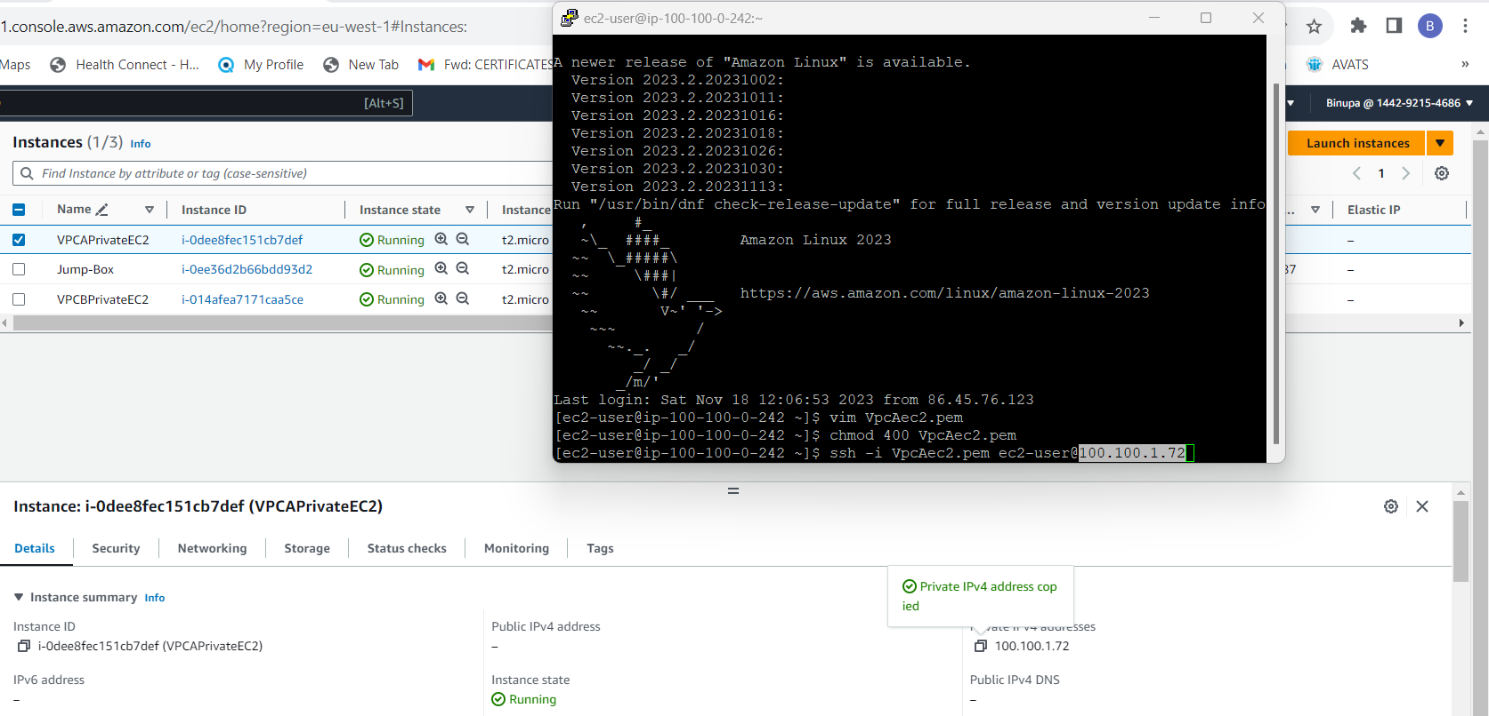

SSH connection from VPCA private subnet to VPCB private subnet

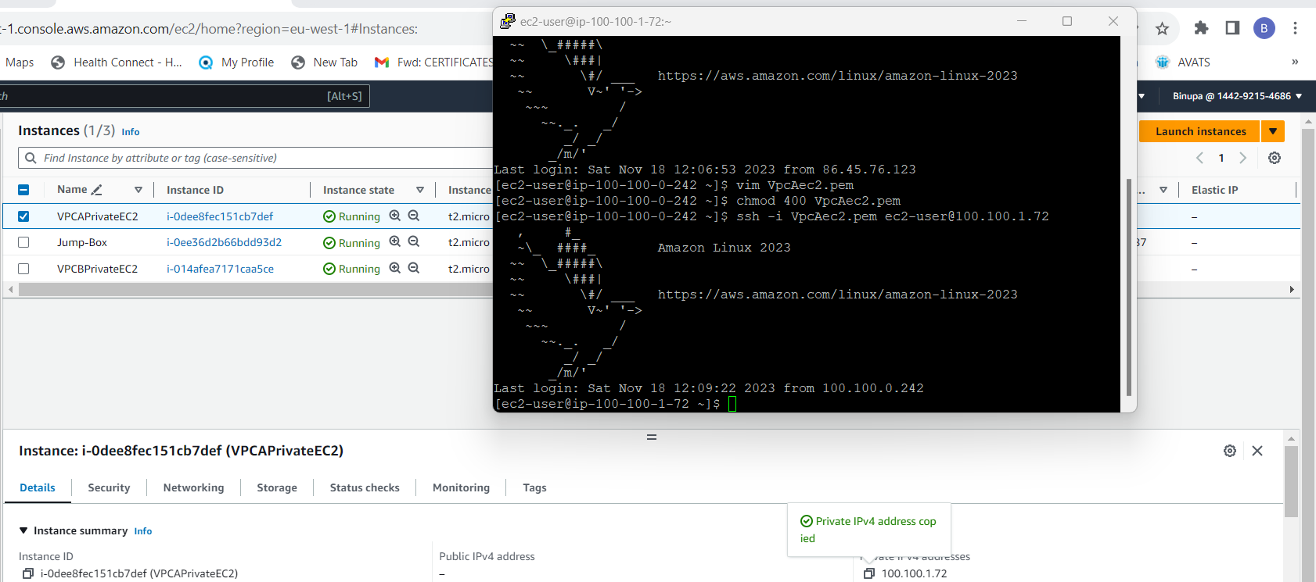

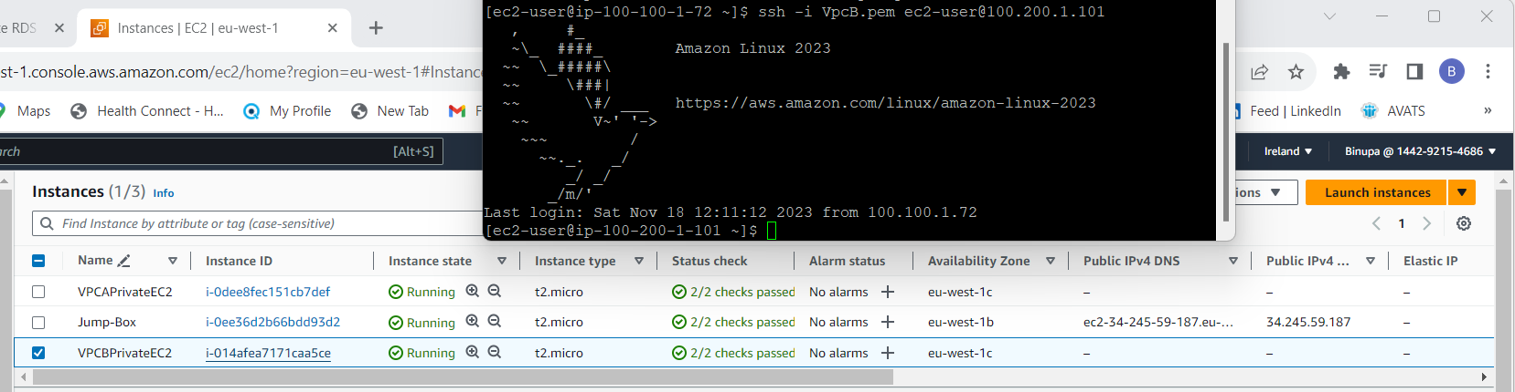

Ping from VPCB private subnet to VPCA private subnet

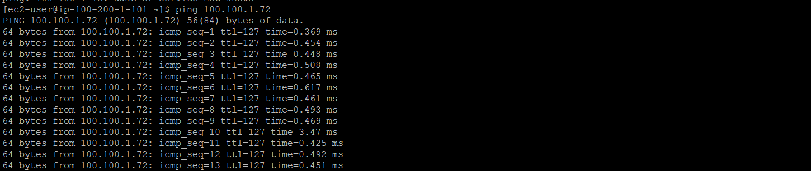

Created an RDS instance in VPCB private subnet

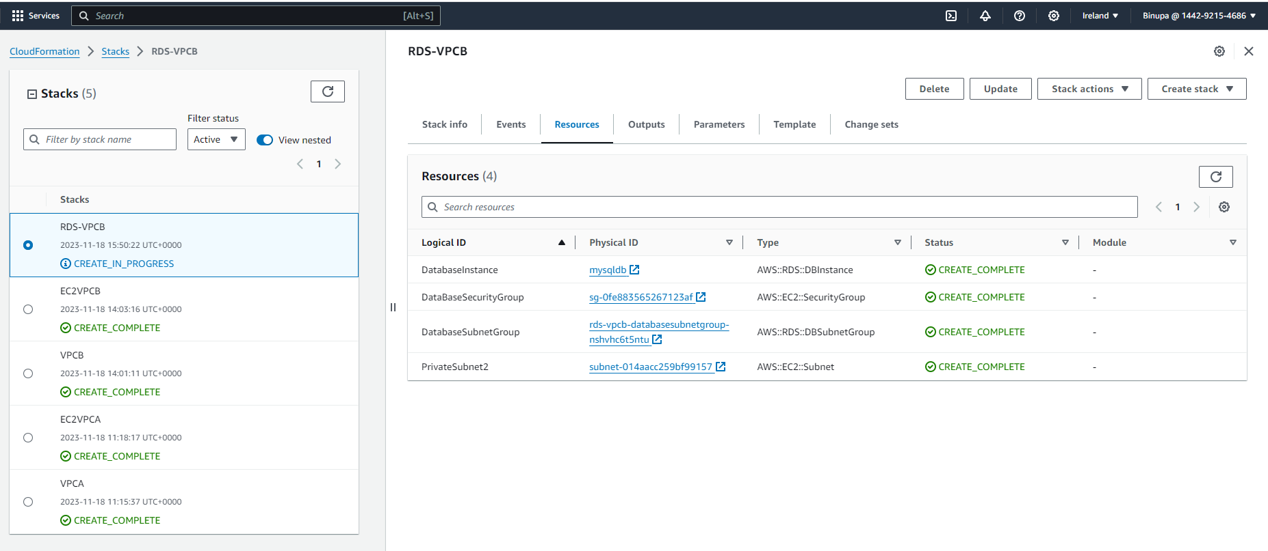

# **Graphical representation of templates**

VPCAWithPublicandPrivateSubnet.yml

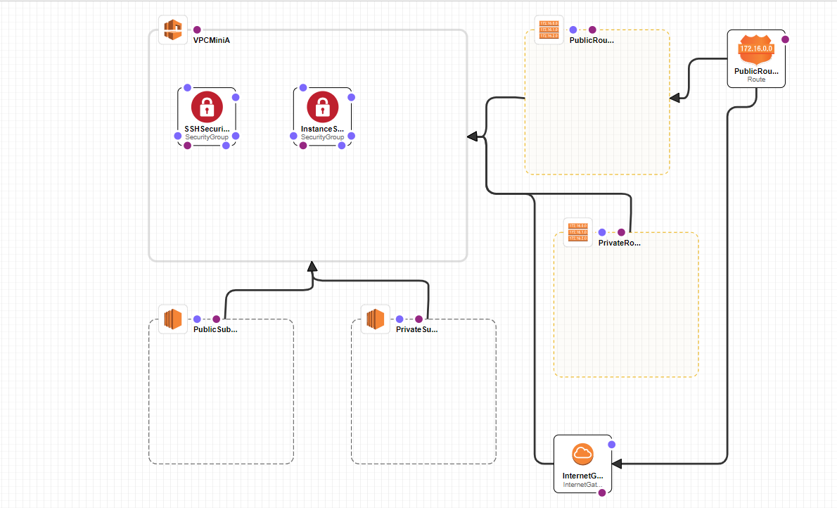

InstanceVPCA.yml

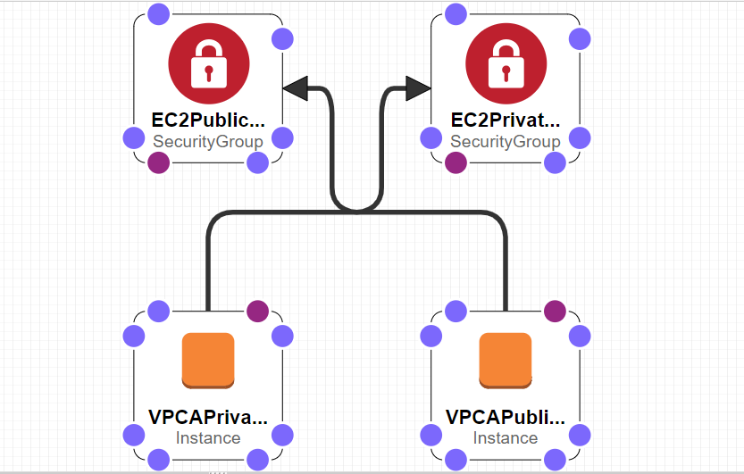

VPCBWithPrivateSubnet.yml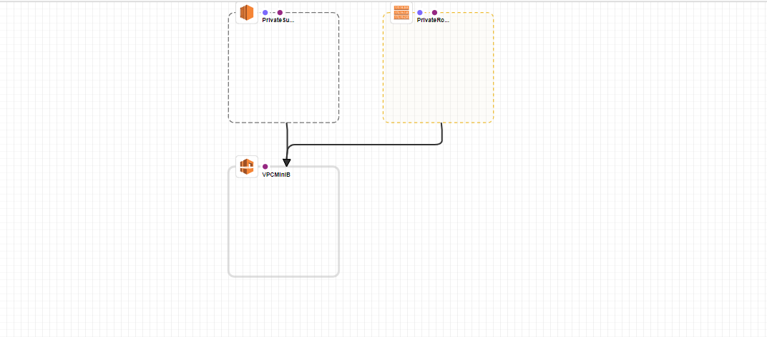  
InstanceVPCB.yml

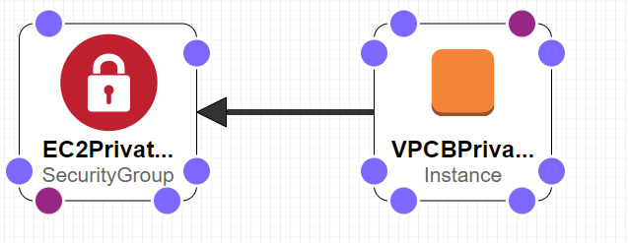

RDS.yml

